How to remove one of three MW3 nodes?

User Scenario: I bought a suite (3 nodes) and they are in the same mesh network system. I want to give one of three nodes to my friend and use independently.

Solution:

You need to remove the node by using Tenda WiFi App.

Step 1: Open App, select the node you want to remove.

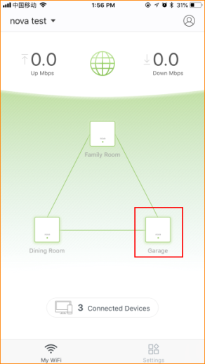
Step 2: Tap “…” on top right.
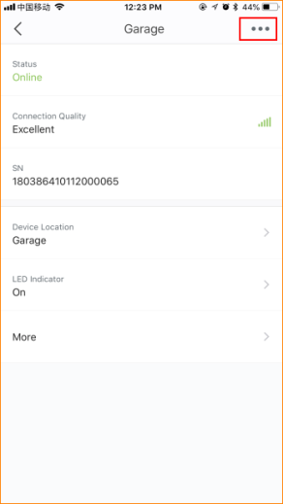

Step 3: Tap “Delete” to remove the node.
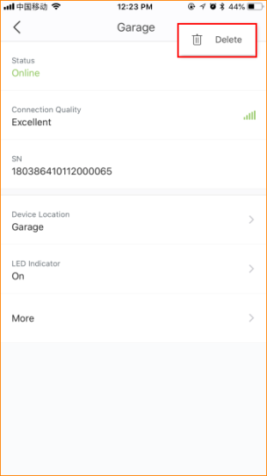

Note:

In one suite all nodes are in the same mesh network system. When you configure primary node (The first one you configure) to access internet, other nodes will synchronize configurations of primary node (E.g: SSID and password.)

